Hardware Programs

DFT

#include<stdio.h>

#include<math.h>

void main()

{

int k,n,N;

float static X[100],X_Real[100],X_Imag[100];

printf("\n Enter the number samples in the sequence X(n)=");

scanf("%d",&N);

printf("Enter the number samples of sequence X(n)\n");

for(n=0;n<N;n++)

{

printf("X(%d)=",n);

scanf("%f",&X[n]);

}

for(k=0;k<N;k++)

{

X_Real[k] = X_Imag[k]=0.0;

for(n=0;n<N;n++)

{

X_Real[k]=X_Real[k]+X[n]*cos((2*M_PI*k*(n-N))/N);

X_Imag[k]=X_Imag[k]+X[n]*sin((2*M_PI*k*(n-N))/N);

}

X_Imag[k]=X_Imag[k]*(-1.0);

}

printf("\nThe %d point DFT of given sequence is:\n",N);

printf("\n\nReal X(k)\t\tImaginary X(k)\n");

for(k=0;k<N;k++)

printf("\nX(%d)= %f\t\t%f\t\t",k,X_Real[k],X_Imag[k]);

getch();

}

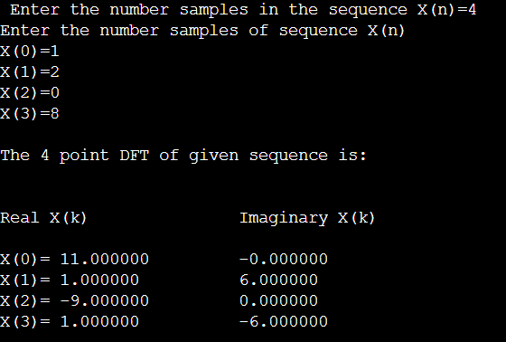

IDFT

#include<stdio.h>

#include<math.h>

void main()

{

float static X[100],X_Real[100],X_Imag[100];

int k,n,N;

printf("\n\n Enter the length of DFT N=");

scanf("%d",&N);

printf("\n Enter the real and imaginary parts of X(k) as follows:\n\n"

"X(k) =Real{X(k)} Img{X(k)} \n" );

for(k=0;k<N;k++)

{

printf("X(%1.0d)=",k);

scanf("%f%f",&X_Real[k],&X_Imag[k]);

}

for(n=0;n<N;n++)

{

X[n]=0;

for(k=0;k<N;k++)

{

X[n]=X[n]+X_Real[k]*cos((2*M_PI*k*n)/N)-X_Imag[k]*sin((2*M_PI*k*n)/N);

}

X[n]=X[n]/N;

}

printf("\n\n The sequence x(n) is ");

for(n=0;n<N;n++)

{

printf("\n\n X(%1.0d)=%3.6f",n,X[n]);

}

getch();

}

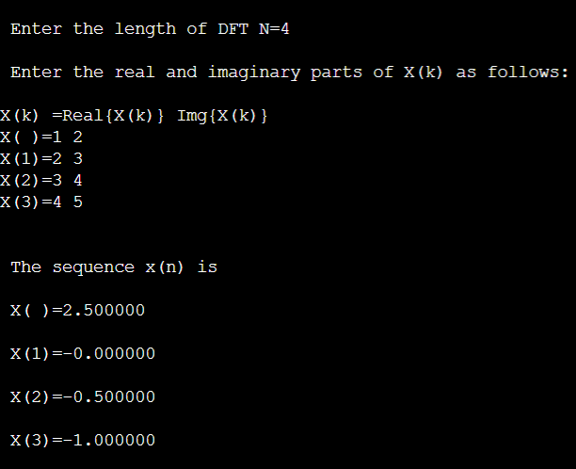

Linear Convolution

#include<stdio.h>

int x[15],h[15],y[15];

main()

{ int i,j,l,m;

printf("\n enter value for l:\n");

scanf("%d",&l);

printf("\n enter value for m:\n");

scanf("%d",&m);

printf("Enter values for i/p x(n):\n");

for(i=0;i<l;i++)

scanf("%d",&x[i]);

printf("Enter Values for i/p h(n) \n");

for(i=0;i<m; i++)

scanf("%d",&h[i]);

for(i=l;i<=l+m-1;i++)

x[i]=0;

for(i=m;i<=l+m-1;i++)

h[i]=0;

for(i=0;i<l+m-1;i++)

{

y[i]=0;

for(j=0;j<=i;j++)

{

y[i]=y[i]+(x[j]*h[i-j]);

}

}

for(i=0;i<l+m-1;i++)

printf("\n The Value of output y[%d]=%d",i,y[i]);

}

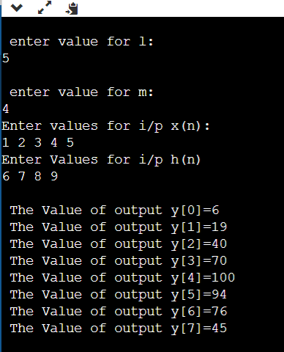

Circular Convolution

#include<stdio.h>

int m,n,x[30],h[30],y[30],i,j, k,x2[30],a[30];

void main()

{

printf(" enter the length of the first sequence\n");

scanf("%d",&m);

printf(" enter the length of the second sequence\n");

scanf("%d",&n);

printf(" enter the first sequence\n");

for(i=0;i<m;i++)

scanf("%d",&x[i]);

printf(" enter the second sequence\n");

for(j=0;j<n;j++)

scanf("%d",&h[j]);

if(m-n!=0)

{

if(m>n)

{

for(i=n;i<m;i++)

h[i]=0;

n=m;

}

for(i=m;i<n;i++)

x[i]=0;

m=n;

}

y[0]=0;

a[0]=h[0];

for(j=1;j<n;j++)

a[j]=h[n-j];

for(i=0;i<n;i++)

y[0]+=x[i]*a[i];

for(k=1;k<n;k++)

{

y[k]=0;

for(j=1;j<n;j++)

x2[j]=a[j-1];

x2[0]=a[n-1];

for(i=0;i<n;i++)

{

a[i]=x2[i];

y[k]+=x[i]*x2[i];

}

}

printf(" the circular convolution is\n");

for(i=0;i<n;i++)

printf("%d \t",y[i]);

}

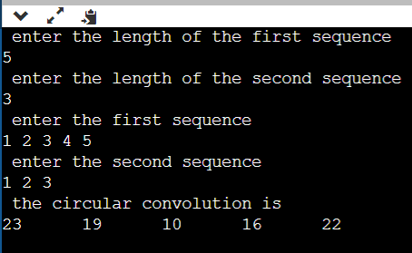

FIR